Chapter 1: Introduction

- \*\***Introduction to Project**:** The Fitness Exercise Website aims to establish an interactive platform dedicated to promoting fitness and well-being through exercise. It will provide users with access to diverse workout routines, personalized training plans, nutrition advice, and a supportive community environment.

\*\***Project Category**:** The project falls under Internet-based application development, emphasizing accessibility through online access.

\*\***Objectives**:** To create a user-centric platform with personalized fitness plans, comprehensive exercise databases, nutrition guidance, and a community-driven atmosphere fostering encouragement and support.

\*\***Existing** **System**:** Certainly! Some limitations of current fitness-related platforms include:

1. **Lack of Personalization:** Many platforms offer generalized workout plans that might not cater to individual fitness levels, goals, or preferences. Lack of personalized recommendations can hinder users from achieving optimal results.

2. **Limited Exercise Variety:** Some platforms provide a limited range of exercises or routines, which might not suit diverse user needs or offer enough variety to keep users engaged.

3. **Inadequate Nutrition Guidance:** While exercise routines are often provided, comprehensive guidance on nutrition and dietary habits is often lacking. A holistic approach to fitness involves a balance between exercise and nutrition.

4. **Minimal Interactivity and Engagement:** Some platforms lack interactive features or community support mechanisms. Users might feel isolated without the ability to engage with others, share experiences, or receive motivation and support.

5. **Inaccurate Progress Tracking:** Some platforms may lack robust tools for tracking progress accurately, such as detailed metrics, charts, or analysis, which are crucial for users to monitor and assess their improvements.

6. **Accessibility and User Experience:** Poor user interface design or lack of compatibility with various devices may limit accessibility and hinder a seamless user experience.

7. **Limited Content Updates:** Outdated or stagnant content can reduce user engagement and motivation. Platforms that do not regularly update content may fail to retain users' interest in the long run.

8. **Data Privacy and Security Concerns:** Inadequate measures to protect user data can lead to concerns about privacy and security, potentially deterring users from using the platform.

9. **Cost and Accessibility:** Some fitness platforms might have subscription fees or costly plans, making them inaccessible to certain demographics or limiting users' ability to access premium features.

10. **Lack of Integration with Wearable Devices:** Failure to integrate with wearable fitness devices can limit the user experience and the ability to track and sync real-time data.

\*\***Proposed** **System**:** The Fitness Exercise Website aims to address the limitations of current fitness-related platforms by offering comprehensive solutions:

1. **Personalized Fitness Plans:** The website provides personalized workout plans tailored to individual fitness levels, goals, and preferences. Users input their information, and the platform generates customized routines to optimize results.

2. **Diverse Exercise Database:** A wide range of exercises across various categories (strength training, cardio, yoga, etc.) caters to diverse user needs and preferences, ensuring a variety of options to keep users engaged and motivated.

3. **Comprehensive Nutrition Guidance:** In addition to workout routines, the platform offers guidance on nutrition, healthy eating habits, meal plans, recipes, and dietary advice. This holistic approach complements exercise regimens for overall well-being.

4. **User-Centric Design:** The website is designed with user experience in mind, ensuring accessibility across various devices (desktops, tablets, mobile phones) and offering an intuitive interface for seamless navigation.

5. **Regular Content Updates:** Continuous updates with fresh content, new exercises, nutritional information, and engaging features keep users interested and motivated to stay committed to their fitness goals.

6. **Data Privacy and Security Measures:** Strong security measures protect user data and privacy, ensuring a safe and trustworthy environment for users to engage with the platform.

\*\***Unique** **Features** **of** **the** **System** The website provides personalized workout plans tailored to individual fitness levels, goals, and preferences.

A wide range of exercises across various categories (strength training, cardio, yoga, etc.) caters to diverse user needs and preferences, ensuring a variety of options to keep users engaged and motivated.

Chapter 2: Requirement Analysis and System Specification

- \*\***Feasibility Study**:** Evaluates technical, economical, and operational feasibility to justify the viability and practicality of the project.

- \*\***Software Requirement Specification (SRS) Document**:** Software tools like VS code,

Git,etc.

- \*\***Expected Hurdles**:**

1. **Technical Challenges:**

- **Solution:** Continuous research and development to stay updated with the latest technologies and tools. Encourage the team to participate in training programs or workshops to enhance technical skills. Additionally, maintain a pool of experienced developers who can provide guidance and solutions to complex technical issues.

2. **Resource Constraints:**

- **Solution:** Conduct thorough resource planning at the project's initiation phase to ensure adequate allocation of human resources, technology, and finances. Regularly monitor resource utilization and adjust plans accordingly. Consider outsourcing specific tasks if necessary.

4. **Timeline and Deadline Pressures:**

- **Solution:** Develop a realistic project schedule considering all phases of development, testing, and deployment. Use project management tools like Gantt charts to track progress and identify potential delays early. Allocate buffer time for unforeseen circumstances.

6. **Quality Assurance and Testing Challenges:**

- **Solution:** Implement robust testing methodologies from the initial stages of development. Conduct frequent code reviews, perform comprehensive testing, and ensure adherence to quality standards. Allocate sufficient time and resources for testing and bug fixing.

- \*\***SDLC Model**:** The software development cycle for the Fitness Exercise Website involves several stages, each crucial for the successful creation, implementation, and maintenance of the platform. Here's an overview of the software development cycle adapted for the Fitness Exercise Website:

1. **Planning and Analysis:**

- **Requirements Gathering:** Collaborate with stakeholders, including fitness experts, nutritionists, potential users, and development teams, to gather detailed requirements for the website. Define project scope, objectives, and user personas.

- **Market Research:** Analyze existing fitness platforms, identify their strengths and weaknesses, and determine what unique value the Fitness Exercise Website can offer.

2. **Design Phase:**

- **System Design:** Use tools like UML, DFDs, and wireframes to visualize the system architecture, database structure, user interface, and functionalities. Create mockups and prototypes for user testing and feedback.

- **User Experience Design:** Focus on creating an intuitive, user-friendly interface with considerations for usability and accessibility across different devices.

3. **Development Phase:**

- **Front-end Development:** Implement the user interface and interactive features using HTML, CSS, JavaScript, and frameworks like ReactJS to ensure a responsive design.

4. **Testing Phase:**

- **Unit Testing:** Conduct individual component testing to ensure each part of the system functions correctly.

- **Integration Testing:** Verify that different modules integrate seamlessly and work together as a cohesive system.

- **User Acceptance Testing (UAT):** Invite users to test the website, gather feedback, and make necessary improvements based on their experiences.

5. **Deployment Phase:**

- **Deployment Strategy:** Choose a suitable hosting environment and deploy the website ensuring stability, scalability, and security.

- **Monitoring and Performance Testing:** Monitor the live website for performance issues, load times, and server responsiveness. Conduct stress testing to assess the website's ability to handle traffic spikes.

6. **Maintenance and Iteration:**

- **Bug Fixing and Updates:** Address any issues reported after the website goes live. Regularly update content, add new exercises, and improve features based on user feedback and emerging trends.

- **Security Updates:** Implement regular security patches and updates to protect user data and maintain a secure environment.

Chapter 3: System Design

- \*\***Design Approach**:**

* Modularity and Reusability
* Inheritance
* Flexibilty and Scalability
* Adapatbility to changing requirements

- \*\***User Interface design**:**

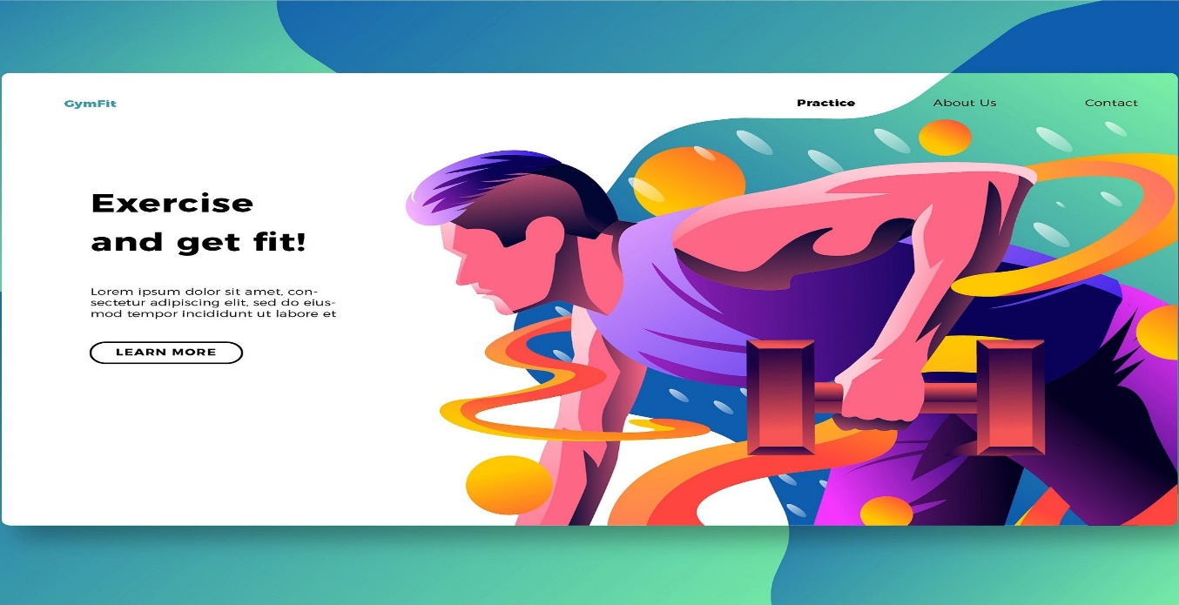

- \*\***ER Diagram**:**

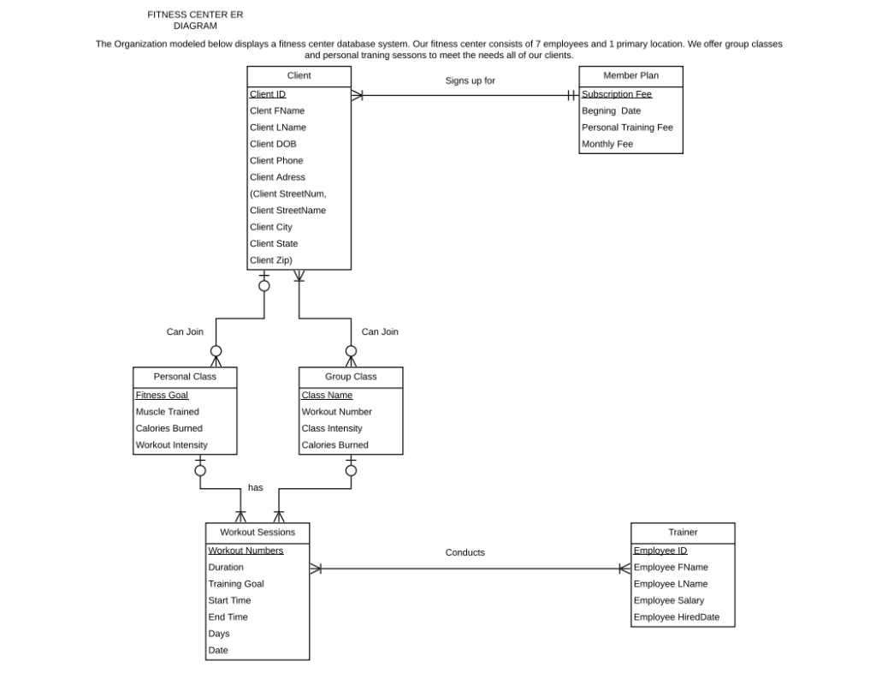

Chapter 4: Implementation, Testing, and Maintenance

- \*\***Introduction to Languages, IDE’s, Tools, and Technologies**:**

* HTML: HTML (HyperText Markup Language) is a standard markup language used for creating the structure and content of web pages, utilizing tags to define elements like headings, paragraphs, links, and images. It forms the backbone of the web, facilitating the display and organization of information on browsers.
* CSS: CSS (Cascading Style Sheets) is a styling language used to control the presentation and appearance of HTML elements, allowing developers to define layout, colors, fonts, and other visual aspects of web pages. It complements HTML by enhancing the aesthetic and design elements of websites, creating visually appealing and responsive user interfaces.
* JavaScript: JavaScript is a versatile programming language primarily used for creating dynamic and interactive elements on web pages, enabling functionalities like user interactions, animations, form validations, and dynamic content updates. As a client-side scripting language, JavaScript executes code within the user's browser, enhancing the overall user experience on websites.
* Vscode: Visual Studio Code (VSCode) is a free, open-source code editor developed by Microsoft, renowned for its versatility and extensive customization options. It supports various programming languages and offers features like IntelliSense, debugging tools, extensions, and a user-friendly interface, making it a popular choice among developers for efficient and streamlined coding workflows.

- \*\***Testing Techniques and Test Plans**:** Certainly! Here's an outline of methodologies for testing, as well as plans for ongoing maintenance:

**Testing Methodologies:**

1. **Functionality Testing:**

- **Unit Testing:** Individual components are tested in isolation to ensure they function as expected.

- **Integration Testing:** Modules are tested together to verify interactions and integration between components.

- **System Testing:** The entire system is tested as a whole to ensure all functionalities work together smoothly.

2. **Usability Testing:**

- **User Testing:** Inviting actual users to interact with the website and provide feedback on its usability, intuitiveness, and overall user experience.

- **User Interface (UI) Testing:** Checking the interface for consistency, responsiveness, and adherence to design standards.

3. **Security Testing:**

- **Vulnerability Assessment:** Identifying and mitigating potential security threats, such as SQL injection, cross-site scripting (XSS), and other vulnerabilities.

- **Penetration Testing:** Simulating cyberattacks to detect weaknesses in the website's security measures.

4. **Performance Testing:**

- **Load Testing:** Assessing the website's response under various loads to ensure it performs well under expected user traffic.

- **Stress Testing:** Evaluating the system's stability under extreme loads to identify potential failure points.

**Ongoing Maintenance Plans:**

1. **Bug Fixing and Updates:**

- **Regular Monitoring:** Continuously monitor the website for bugs, errors, or performance issues.

- **Issue Tracking:** Utilize issue-tracking systems to log and prioritize reported issues for efficient resolution.

- **Patch Updates:** Deploy timely patches and updates to address any security vulnerabilities or bugs discovered post-launch.

2. **Content Updates and Enhancements:**

- **Regular Content Refresh:** Keep content updated by adding new exercises, nutritional information, or community engagement features to maintain user interest.

- **Feature Enhancements:** Iteratively add new features or improve existing functionalities based on user feedback and emerging trends.

3. **Security Measures:**

- **Regular Security Audits:** Conduct periodic security audits to identify and address potential security gaps.

- **Security Patching:** Ensure all software components are up-to-date with the latest security patches to mitigate any vulnerabilities.

4. **Performance Optimization:**

- **Monitoring and Tuning:** Continuously monitor website performance and optimize resources to enhance speed and responsiveness.

- **Scalability Planning:** Plan for scalability to accommodate increased user traffic by optimizing server resources or considering cloud-based solutions.

By implementing these testing methodologies and maintenance plans, the Fitness Exercise Website can ensure a robust, secure, and high-performing platform while addressing evolving user needs and industry standards.

Chapter 5: Results and Discussions

- \*\***User Interface Representation**:** The user interface representation of the website is as given below :

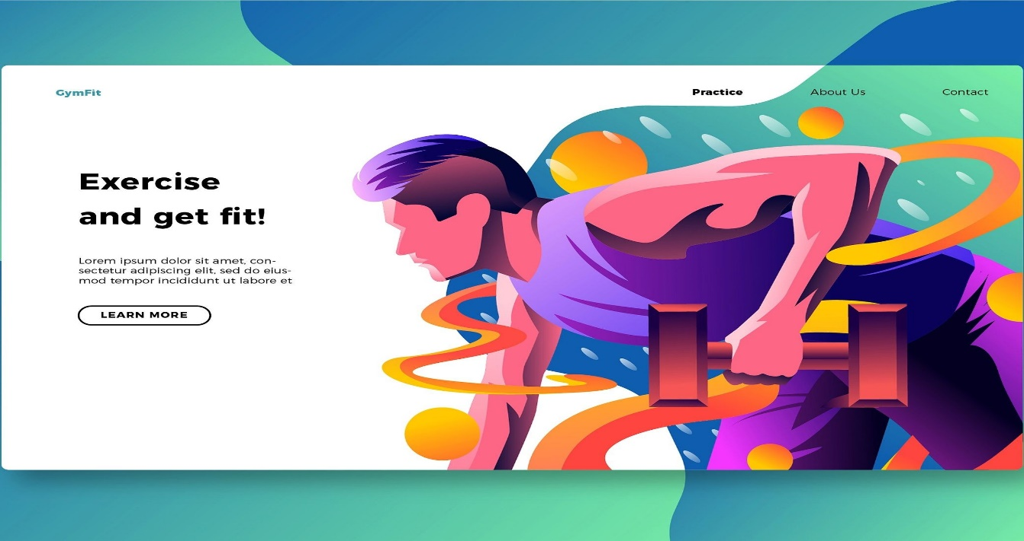

Chapter 6: Conclusion and Future Scope

- \*\***Conclusion**:** The Fitness Exercise Website represents a comprehensive solution aimed at revolutionizing the way individuals engage with fitness routines, nutrition guidance, and community support. Throughout its development, the project has focused on providing a holistic platform that addresses the diverse needs and preferences of users seeking to improve their health and wellness. As the project concludes, the following key points summarize its significance:

1. **Empowerment through Personalized Fitness:** The website offers tailored exercise plans, catering to users' unique fitness levels, objectives, and preferences. This personalized approach ensures users receive targeted guidance, enhancing their motivation and progress.

2. **Holistic Wellness Integration:** By combining exercise routines with nutrition guidance and healthy living tips, the platform encourages users to adopt a holistic approach to their well-being. It emphasizes the interconnectedness of exercise, nutrition, and overall health.

3. **Community Engagement and Support:** The incorporation of interactive features, forums, and social sharing fosters a sense of community among users. This supportive environment allows individuals to connect, share experiences, and inspire each other on their fitness journeys.

4. **Continuous Improvement and Adaptability:** The project embraces a culture on continuous improvement, with plans for ongoing updates, feature enhancements, and regular content refreshes. This commitment ensures that the platform remains relevant, engaging, and responsive to users' evolving needs.

5. **User-Centric Design and Accessibility:** The platform prioritizes user experience, offering an intuitive interface accessible across various devices. Its design aims for ease of navigation, ensuring a seamless and enjoyable experience for users of all levels.

6. **Security and Privacy Commitment:** Robust security measures safeguard user data and privacy, reinforcing trust and confidence in the platform.

In conclusion, the Fitness Exercise Website stands as a valuable resource, providing users with the tools, guidance, and community support necessary to embark on a transformative fitness journey. As the project concludes, its commitment to empowering users towards healthier lifestyles remains unwavering, paving the way for sustained well-being and personal growth in the realm of fitness and health.

- \*\***Future** **Scope**:** The Fitness Exercise Website holds significant potential for future enhancements and expansions, catering to emerging trends and evolving user needs within the fitness and wellness domain. The future scope of the platform includes:

1. **Integration of Advanced Technologies:** Incorporating AI-driven features for personalized workout recommendations based on real-time data from wearable fitness devices. Utilizing machine learning algorithms to adapt and refine exercise plans according to user progress.

2. **Enhanced Gamification and Engagement:** Implementing gamification elements such as challenges, rewards, and virtual fitness competitions to enhance user motivation and engagement. Introducing leaderboards and achievements to encourage healthy competition among users.

3. **Live Workout Sessions and Virtual Coaching:** Offering live streaming of workout sessions conducted by fitness experts and trainers. Providing users with the opportunity to access real-time guidance, ask questions, and participate in interactive training sessions.

4. **Expanded Content and Partner Collaborations:** Partnering with fitness influencers, nutritionists, and health experts to provide a broader range of content, including specialized workout programs, meal plans, and expert advice on specific fitness goals or health conditions.

5. **Localization and Multilingual Support:** Expanding the platform's reach by providing content and support in multiple languages, making it accessible to a wider global audience interested in fitness and well-being.

6. **Augmented Reality (AR) and Virtual Reality (VR) Integration:** Exploring AR/VR technology to create immersive fitness experiences, offering simulated environments or interactive workouts that enhance user engagement and enjoyment.

7. **Analytics and Insights:** Incorporating comprehensive data analytics to offer detailed insights into user progress, trends, and preferences. Providing users with personalized recommendations and actionable insights for better health outcomes.

8. **Partnerships and Corporate Wellness Programs:** Collaborating with corporations to offer wellness programs, providing employees with access to the platform as part of their health benefits, promoting healthier lifestyles and well-being in the workplace.

9. **Accessibility Features:** Continuously improving accessibility features to ensure inclusivity for users with disabilities, offering assistive technologies and adapting the platform for various accessibility needs.

10. **Research and Development:** Investing in research initiatives to explore innovative fitness trends, emerging technologies, and scientific advancements in health and wellness. Incorporating evidence-based practices to improve the effectiveness of fitness routines and nutrition guidance.

By embracing these future scopes, the Fitness Exercise Website can evolve into a more comprehensive, inclusive, and technologically advanced platform, further cementing its position as a leading resource for individuals seeking to achieve their fitness goals and maintain a healthy lifestyle.

- \*\***References/Bibliography**:** Certainly! Here's an example of how the References/Bibliography section for the Fitness Exercise Website project report might be structured:

1. Smith, J. (2021). "The Science of Fitness." Publisher Name.

2. Johnson, A. (2022). "Nutrition and Exercise: A Comprehensive Guide." Journal of Health and Wellness, 15(2), 112-128.

3. World Health Organization. (2018). "Global Recommendations on Physical Activity for Health." Retrieved from [https://www.who.int/publications/i/item/9789241599979](<https://www.who.int/publications/i/item/9789241599979>)

4. Mozilla Developer Network. (n.d.). "HTML: HyperText Markup Language." Retrieved from [https://developer.mozilla.org/en-US/docs/Web/HTML](https://developer.mozilla.org/en-US/docs/Web/HTML)

5. W3Schools. (n.d.). "CSS Tutorial." Retrieved from [https://www.w3schools.com/css/](https://www.w3schools.com/css/)

6. JavaScript MDN Web Docs. (n.d.). "JavaScript." Retrieved from [https://developer.mozilla.org/en-US/docs/Web/JavaScript](https://developer.mozilla.org/en-US/docs/Web/JavaScript)

7. Microsoft. (n.d.). "Visual Studio Code Documentation." Retrieved from [https://code.visualstudio.com/docs](https://code.visualstudio.com/docs)

8. Agile Alliance. (n.d.). "Agile Methodology." Retrieved from [https://www.agilealliance.org/agile101/](https://www.agilealliance.org/agile101/)

9. ISTQB - International Software Testing Qualifications Board. (n.d.). "Software Testing." Retrieved from [https://www.istqb.org/](https://www.istqb.org/)

10. Project Management Institute. (n.d.). "Project Management Tools and Techniques." Retrieved from [https://www.pmi.org/](https://www.pmi.org/)